MARKETING &SALES

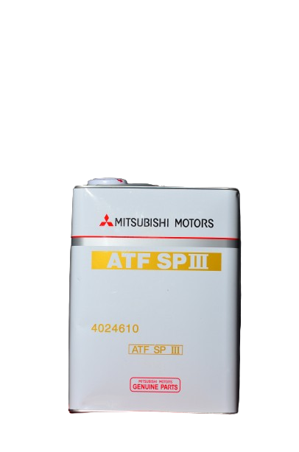

ATF SP 111 for automatic transmission fluid (420a Mitsubishi Eclipse). This is a more developed version with better low temperature properties and longer drain life intervals and shift durability.It is sold individually in 1- quart bottles with universal applications in all Mitsubishi vehicle models.

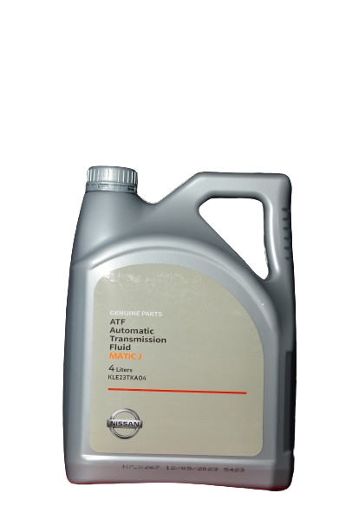

If you have a Nissan vehicle, you’ve most likely used the transmission fluid approved by Nissan, like Matic S, D, J, or K. Nissan Matic-J is a high-quality fluid that maintains a clean transmission system, which in turn runs smoothly. For smooth shifting, this ATF has additional friction modifiers which provide anti-shudder protection. It ensures smooth transmission operation regardless of the temperatures. During high temperatures, the lubricant withstands high pressure, and in cold weather, it distributes evenly. Therefore, high performance is continuous. Also, the fluid provides cooling to the transmission system during hot weather.

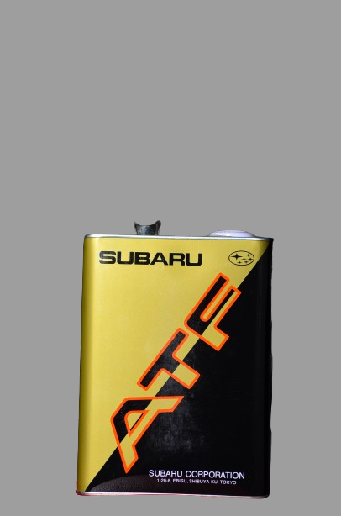

This Subaru ATF is suitable for all Subaru vehicle models with multiple features such as;

* **Withstands** the rigors of heavy towing, elevated temperatures and challenging terrain
* **Remains fluid** in sub-zero temperatures
* **Provides** reserve protection during heavy use and abuse

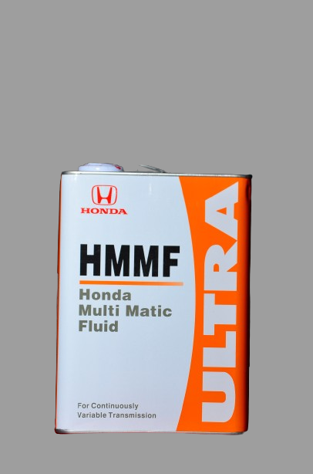

Honda Ultra multi matic fluid (HMMF) is a Continuous variable transmission fluid for Honda vehicle models.  It **cannot** be used for vehicles equipped with the newer CVT (HCF-2 designated vehicles). [If your Honda vehicle requires HCF-2, make sure to use the correct fluid](https://automantransmission.com/product/honda-hmmf-cvt-honda-multi-matic-fuel/).

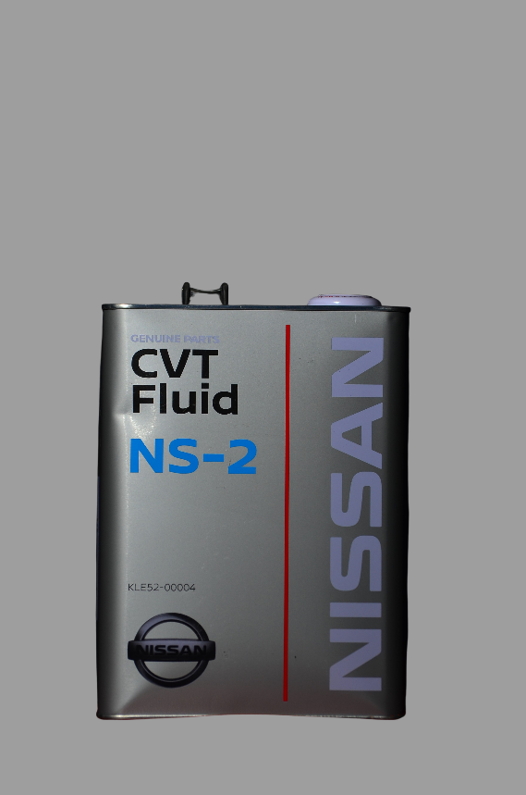

Nissan recommends NS-2 for use in most CVT automatic transmissions.

Nissan NS-2 Transmission Fluid uses a unique formulation of high quality special friction modifiers and other additives to ensure stable, precise operation over long periods of use.

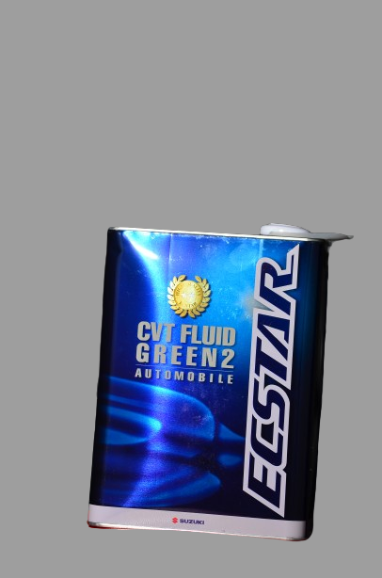

With rising global temperatures and immense efforts being poured by the governments and global corporations to combat climate change,Suzuki came up with a green “darling” which offers all benefits provided by the normal CVTs.In addition to being eco-friendly,this product also has certain, unique features such as;

-Excellent thermal and oxidative stabilityExcellent low temperature fluidity

-Smooth speed changing due to delicately balanced friction coefficient between belt and pulley

-Excellent shear stability

-Offers high wear protection